Lab 2 Solar Cell Modelling using LTSpice
Learning Objectives
By the end of this laboratory, students should be able to:
- Construct a simple solar cell equivalent circuit in LTspice with a diode, current source, and series resistor.
- Measure short-circuit current (I_{SC}) and open-circuit voltage (V_{OC}) using DC operating point simulations.
- Plot I-V and power curves by sweeping voltage sources or stepping load resistance.
- Identify and calculate the Maximum Power Point (MPP) of a solar cell.
- Analyse how changing irradiance and diode parameters affect MPP and load resistance.
- Apply DC-DC buck converters for impedance matching to maximise power transfer for solar cells (optional).

Equipment / Software
LTspice by Analog Devices
The software package can be downloaded at
https://www.analog.com/en/resources/design-tools-and-calculators/ltspice-simulator.html
It is available for both Windows and Mac OS X.

Contents / Procedures
Task 1: Modelling a Simple Solar Cell
In Ref. [1], Ivan Perez Wurfl presents a simple model of a solar cell using a diode, a current source, and a series resistance. Recall that a solar cell is basically a PN junction [2] just like a diode and therefore a diode can be used to model the operation of a solar cell.
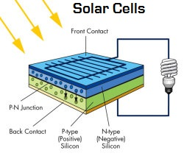
Figure 1 – Solar Cell as a PN Junction [2]
- Set up the model circuit in LTSpice as shown in Figure 2.
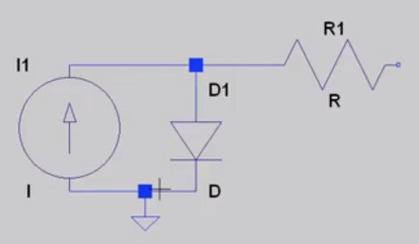
Figure 2 – Solar Cell Model Circuit [1]
Note that in the solar cell model circuit of Figure 2, we’ve added a current source to model light falling on the PV cell causing current to flow through the diode. We’ve also added a series resistor, R1, to model any resistance losses which will occur if we try to draw energy from the cell by connecting a load across its output.
What to do next is to assume that under a particular level of irradiance, the cell produces a current of 3 Amps. Then set the series resistance to 10 mΩ which is typical of a single PV cell. Ref [3] has a cool interactive feature which shows how the cell performance varies as the value of the series resistance changes.
Two important parameters of a PV cell are the short-circuit current and the open-circuit voltage [3].
Short-circuit the output and run the simulation. Choose DC operating point simulation as shown in Figure 3. This gives the results shown in Figure 4 which shows that all of the current flows through the short-circuit.

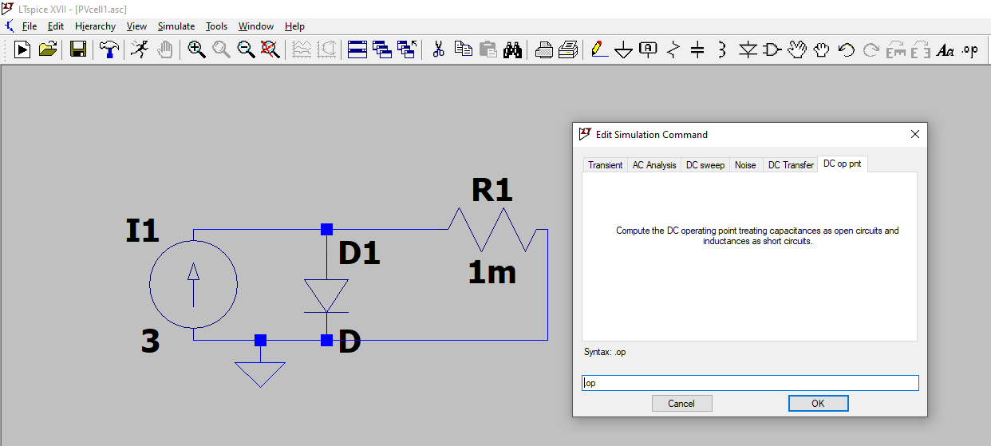
Click here to run
Figure 3 – DC Operating Point Simulation

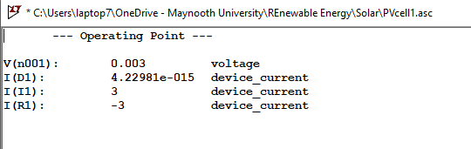
Figure 4 – DC Operating Point Simulation Results
Next, open the output circuit and run the simulation again as shown in Figure 5. Now all of the 3 Amps is flowing through the diode and the voltage dropped across the diode is 0.86 V. The diode is obviously operating in its forward bias region (see Figure 6).
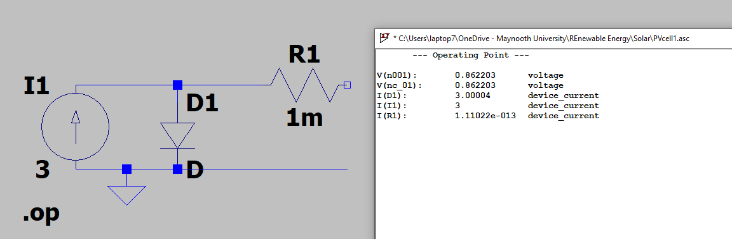
Figure 5 – Open-Circuit DC Operating Point Simulation Results
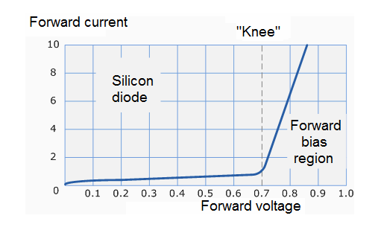
Figure 6 – Typical Forward Biased Example Response of Diode
Now in order to analyse the I-V characteristic of the PV cell model, place a voltage source across the output as shown in Figure 7. Then in the Simulation menu select ‘Edit Simulation Command’ and choose ‘DC sweep’, setting voltage source V1 to a linear sweep from 0 to 0.87 volts in steps of 1 mV as shown. This looks a bit strange putting a voltage source on the output of the solar cell but its actually a clever way to effectively sweep the cell through its full range from short-circuit to open-circuit. That is, when V1 = 0 V, the model circuit will act as if it has a short-circuit on the output and when V1 = 0.86 V, it will act as if it has an open-circuit on the output. So sweeping V1 between 0 and 0.86 V effectively emulates the full range of possible loads on the output.
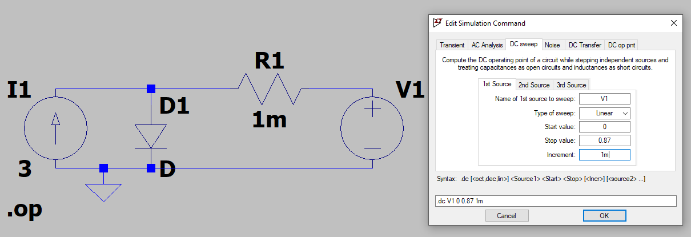
Figure 7 – Circuit for I-V Characteristic of PV Cell
When you run this you get the result shown in Figure 8.
Note how by clicking in the I(V1) label (see graph in Fig 8) you can then drag the dotted line to read any x-y value on the blue response curve.
Now in order to examine the power of the cell, you need to multiply the current by the voltage by right-clicking on the I(V1) label and multiplying it by V1 as shown in Figure 9.

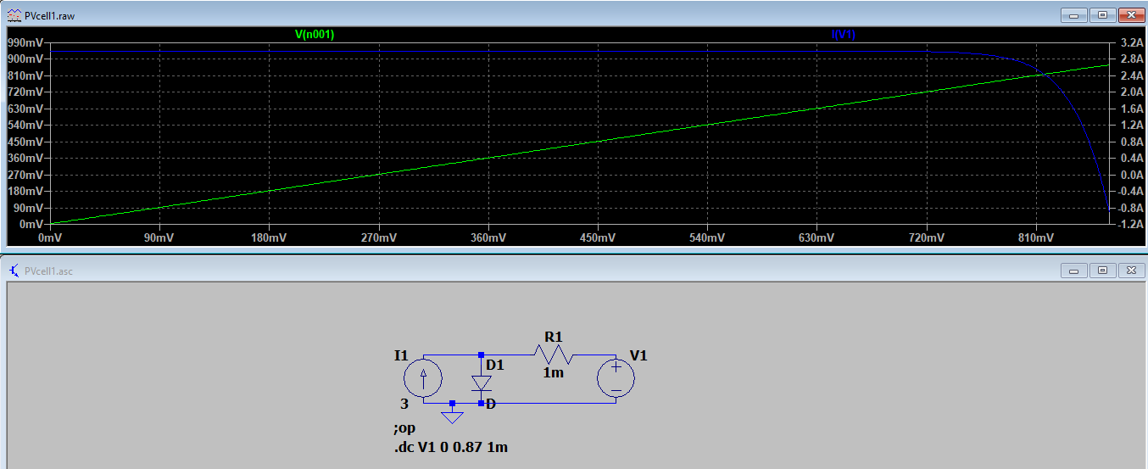
Figure 8 – I-V Characteristic of PV Cell
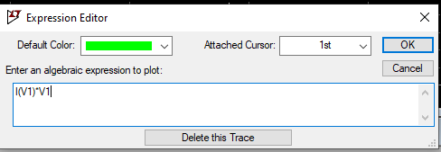
Figure 9 – Measuring the Power of the PV Cell
This results in the response shown in Figure 10
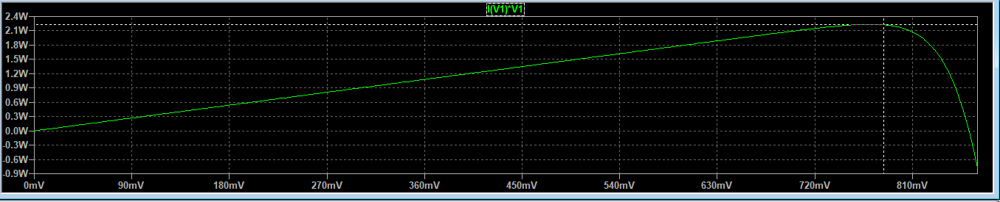
Figure 10 – Power of the PV Cell
Note how you can click on the green I(V1)*V1 label and then drag the vertical dotted line to find the maximum power point of the PV cell as shown in Figure 11. What is the maximum power output?
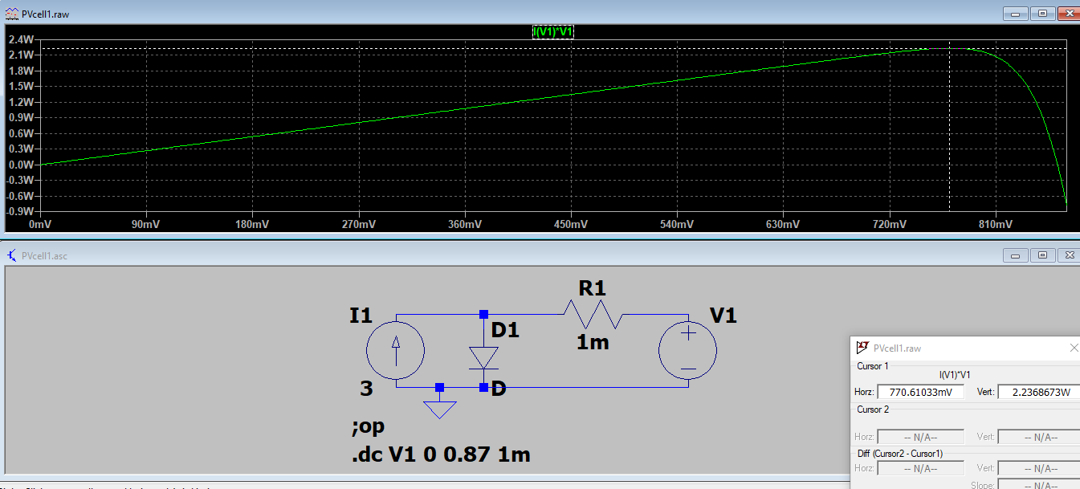
Figure 11 – Maximum Power Point of the PV Cell
Next, change the diode parameters by first right-clicking on the letter ‘D’ associated with the diode. A dialog box opens and rename the diode model to ‘DiodePVCell’. Then click on the ‘.op’ button (simulator directives) in the top right (see Figure 12) of the simulator window and this lets you change the model parameters of this new diode from the default one associated with the default diode model D. Change the saturation current to 10⁻¹⁰ Amps as shown in Figure 12.

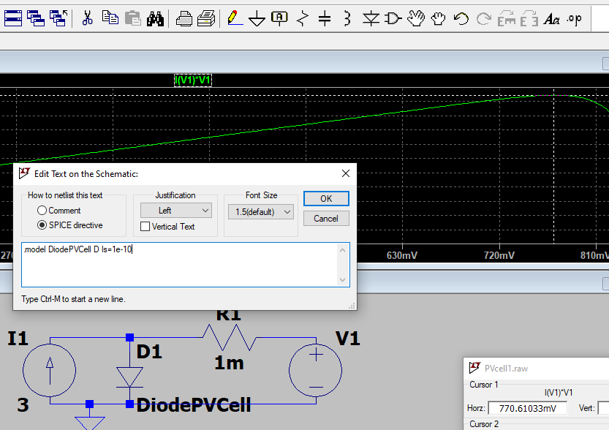
Changing the
Diode Parameters
Figure 12 – Maximum Power Point of the PV Cell
Run the simulation now and observe whether the I-V characteristic has changed.
Next, use the .measure directive, i.e. click on .op (top right) again and type in:
.measure ISC FIND I(V1) WHEN V1=0
Save and run the simulation again and use Ctrl-L to view the result – see Figure 13.
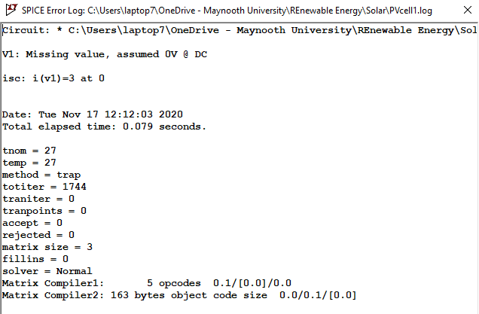
Figure 13 – Short-Circuit Current using .measure directive
Next, add a second .measure directive to the above one by right-clicking on the above .measure directive on the schematic. Note that to do this you need to click your cursor to the right of the above directive and hit Ctrl-Enter to go onto the next line. The second .measure directive is:
.measure VOC FIND V1 WHEN I(V1)=0
That is, find the open-circuit voltage. Save, run and Ctrl-L gives the open-circuit voltage as 0.862 V – see Figure 14.
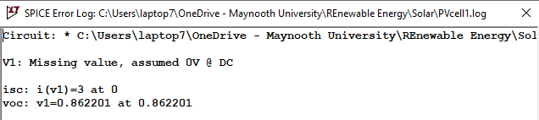
Figure 14 – Open-Circuit Voltage using .measure directive
Finally, add a third .measure directive as shown in Figure 15 and measure the maximum power point of the solar cell directly.
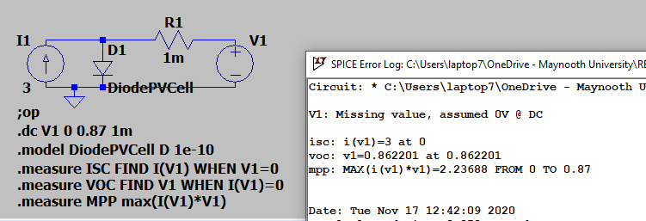
Figure 15 – Max Power Point using .measure directive

Task 2: Varying the load resistance
A more intuitive way to see how the power delivered to the load varies with the value of the load resistance is to use the .STEP directive to increment the load resistance value in small steps (as shown Figure 16).
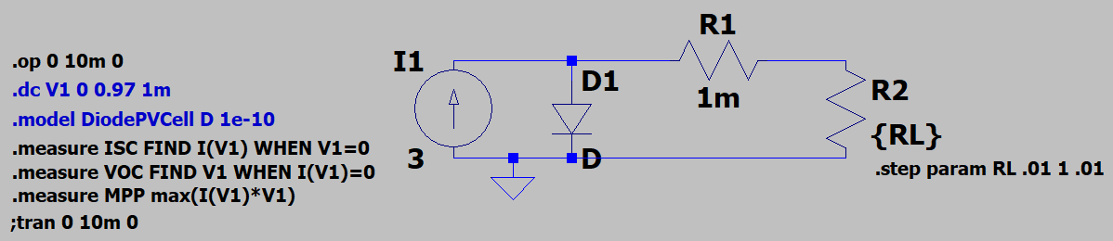
Figure 16 – Using the .step directive to increment the load resistor value
Figure 17 shows the resulting load voltage, current and power for the range of values of the load resistor. This analysis uses the ‘DC operating point’ simulation as shown in Figure 18.
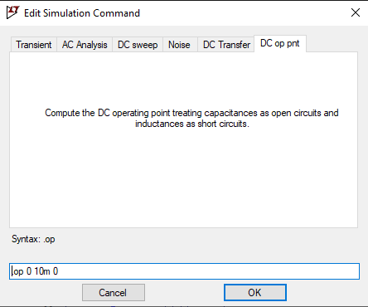
Figure 18 - DC operating point simulation
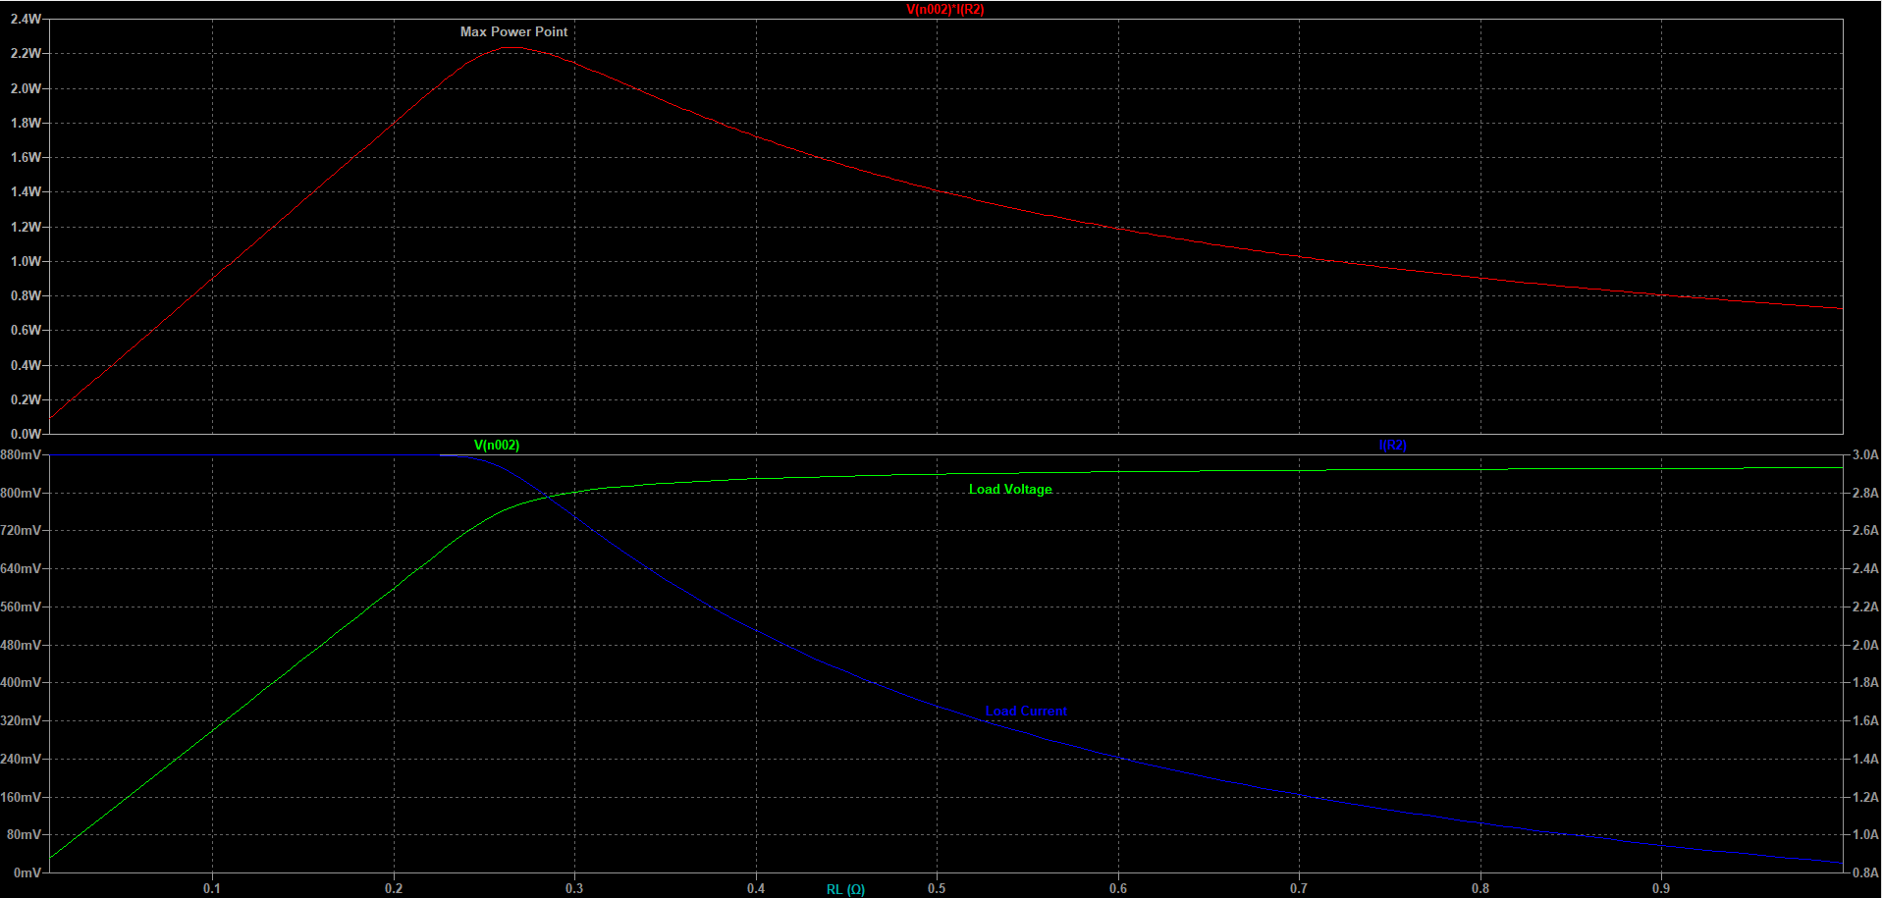
Figure 17 – top: load power; bottom: load current and voltage as a function of load resistance
Questions:
- How does the power delivered to the load depend on the value of the load resistance?
- Identify the maximum power point (MPP) and the load resistance associated to it.
- Estimate the PV cell short-circuit current and open-circuit voltage.
Now changing the source current I1 to 2.5A to simulate a reduction in irradiance, the load current, voltage and power curves become as shown in Figure 18.
Run the simulation again by changing the source current I1 to (1) 2.5 A and (2) 3.5 A to simulate the solar cell under different irradiance. Identify the MPP under these two conditions.
Question: What did you learn from the results (by varying the source current)?

Task 3: Use a Buck Converter to Match the Load Resistor to the MPP (Optional)
In this part of the laboratory, you will try to bring in a buck-boost converter to match the load resistor to the MPP.
For additional information on impedance matching using buck converters, see the supplementary information in DC-DC_Converter_Based_Impedance_Matching_for_Maximum_Power_Transfer_of_CPT_System_with_High_Efficiency.pdf
The input resistance of the buck converter is: $R_{in}=\frac{1}{D^{2}}R_{L}$
So looking at Fig 17 above for which $R_{L_MPP}=0.27 W$ and the max power delivered to this load resistor = 2.237 W.
So let’s say D = 0.5 so that $D^{2}=0.25$ ⇒ $R_{in}=4R_{L}$ so if we make $R_{L}=\frac{0.27}{4}=0.0675W$
then the buck converter should restore the PV cell to its maximum power point.
Demonstrate this analysis through an LTspice simulation. How much power is delivered to the load? Note: a cool way to see the power dissipated in the load (or in any component) is to use Alt-click on the load and it plots the power waveform.
Keeping D = 0.5 and varying R_{L} up or down, how does power delivered change? Similarly, keeping R_{L} = 0.0675Ω and varying D up or down, how does the power delivered change? Draw your conclusion based on the simulation results.

Requirements on the Report
Write up including relevant theory, circuit schematics, results and conclusions.

References:
[1] https://www.youtube.com/watch?reload=9&v=MZ-3HDjwPWw
[2] http://glenergysolar.ie/solar-pv/solar-panels-ireland-how-does-solar-pv-work
[3] https://www.pveducation.org/pvcdrom/solar-cell-operation/series-resistance
[4] https://www.youtube.com/watch?v=Z2C28OXu4xA
[5] https://www.youtube.com/watch?v=EZEQjdZTLA0

